GSS Session-2
dsde0222_gss_s2
Training Clarusway
Pear Deck - June 9, 2022 at 1:41PM

Part 1 - Summary
Use this space to summarize your thoughts on the lesson

Part 2 - Responses
Slide 1


Use this space to take notes:

Slide 2 | Your Response
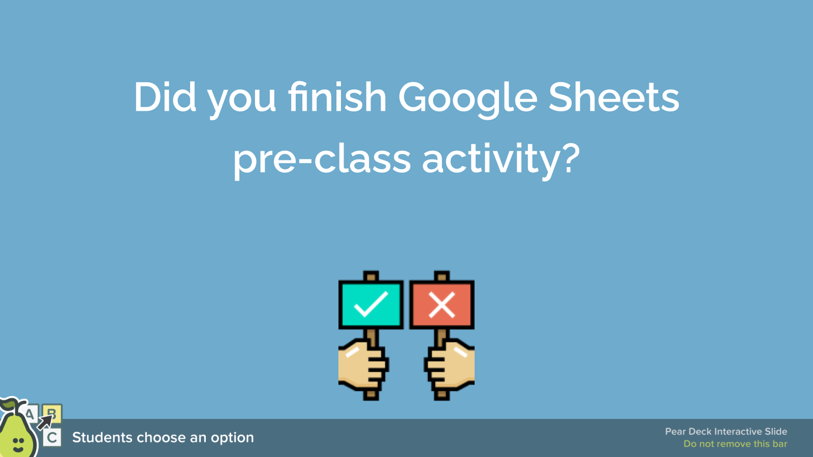 | You Chose  - I finished completely.  Other Choices  - I finished partially.  - No, I didn't finish.
Use this space to take notes:

Slide 3
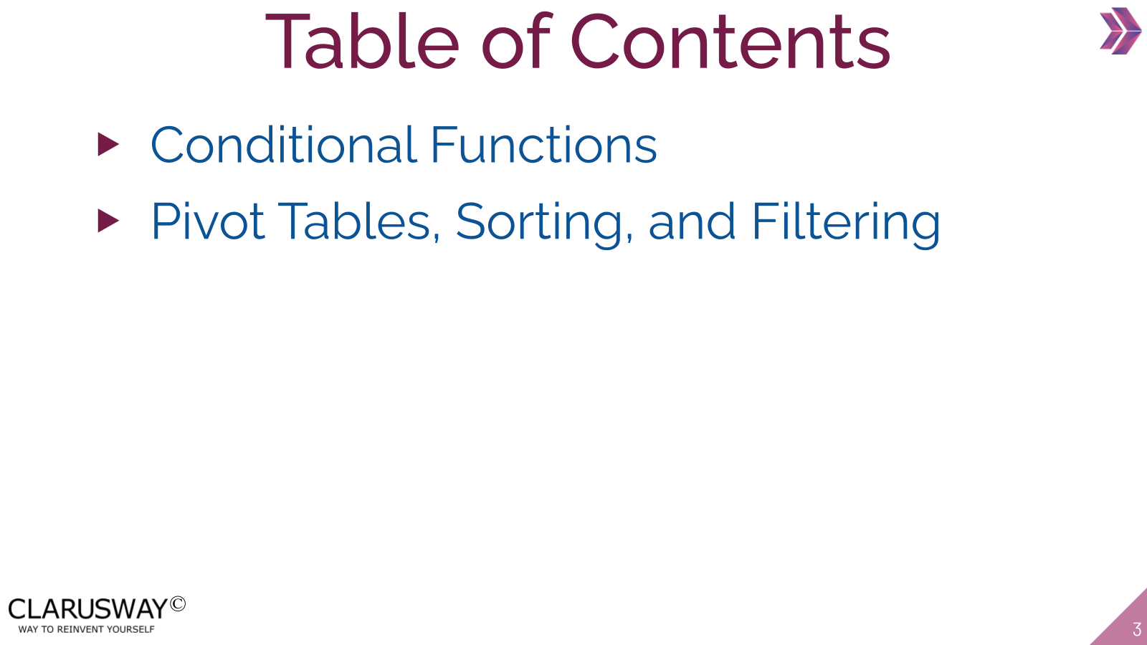

Use this space to take notes:

Slide 4
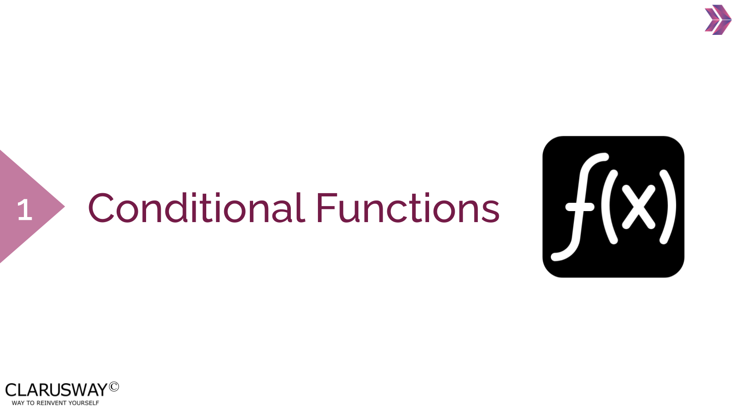

Use this space to take notes:

Slide 5
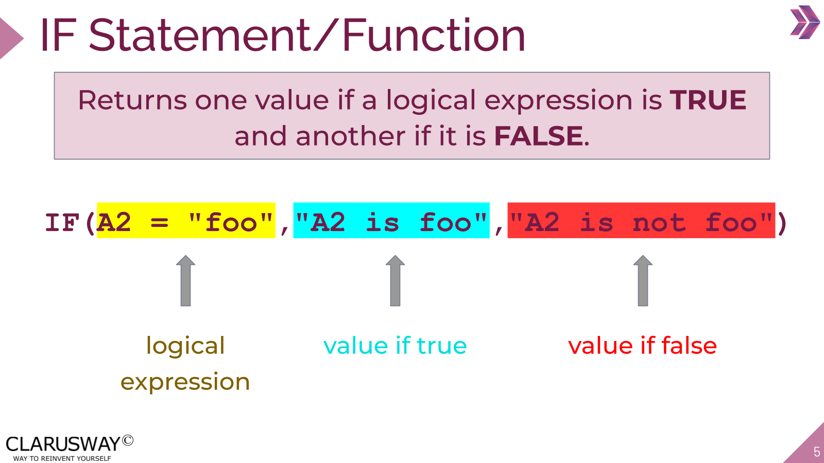

Use this space to take notes:

Slide 6
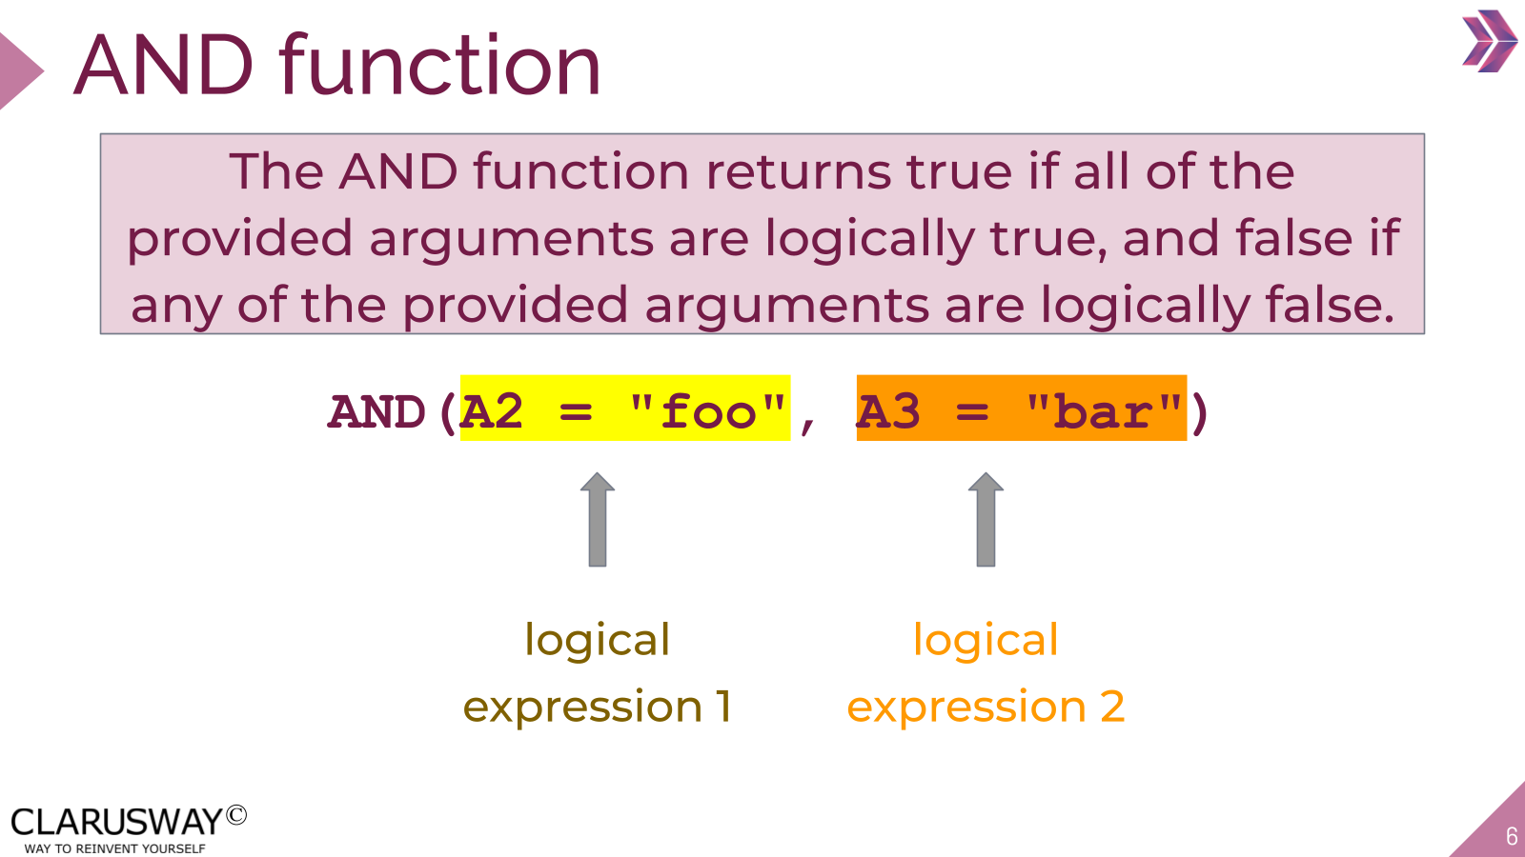

Use this space to take notes:

Slide 7
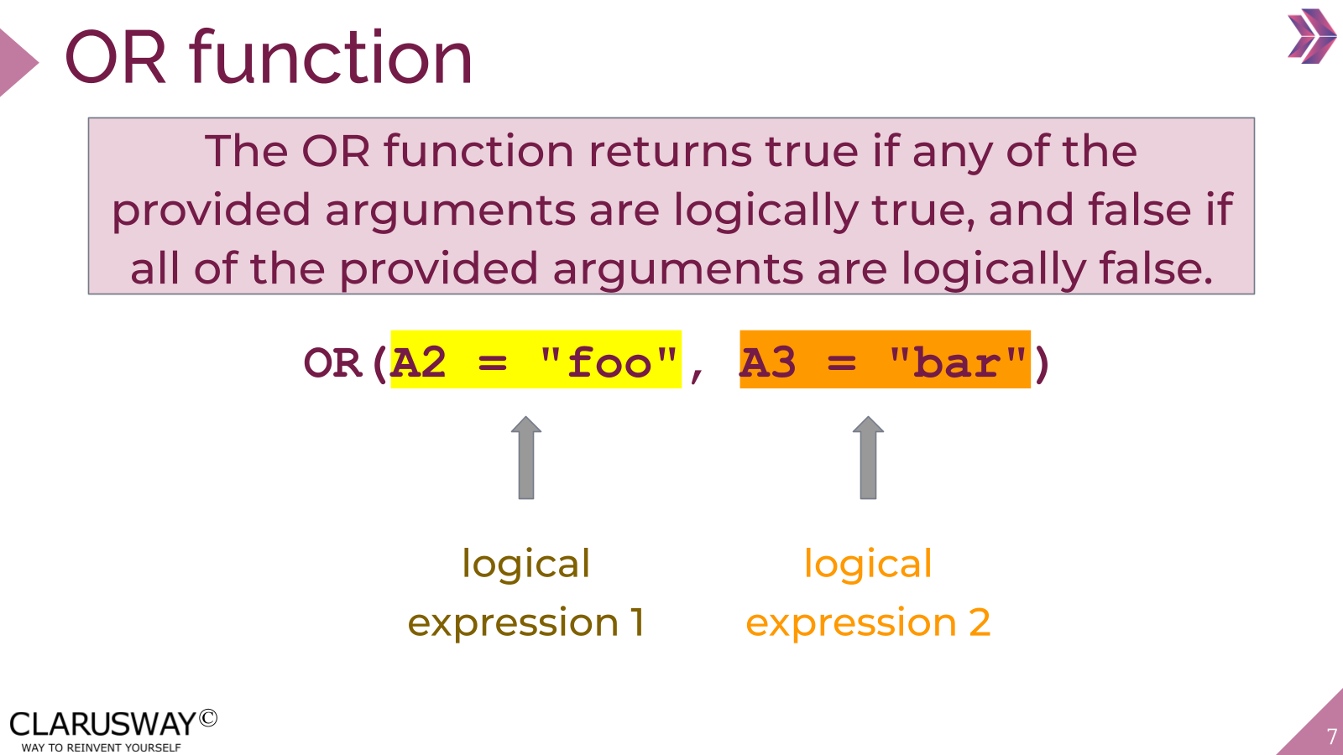

Use this space to take notes:

Slide 8
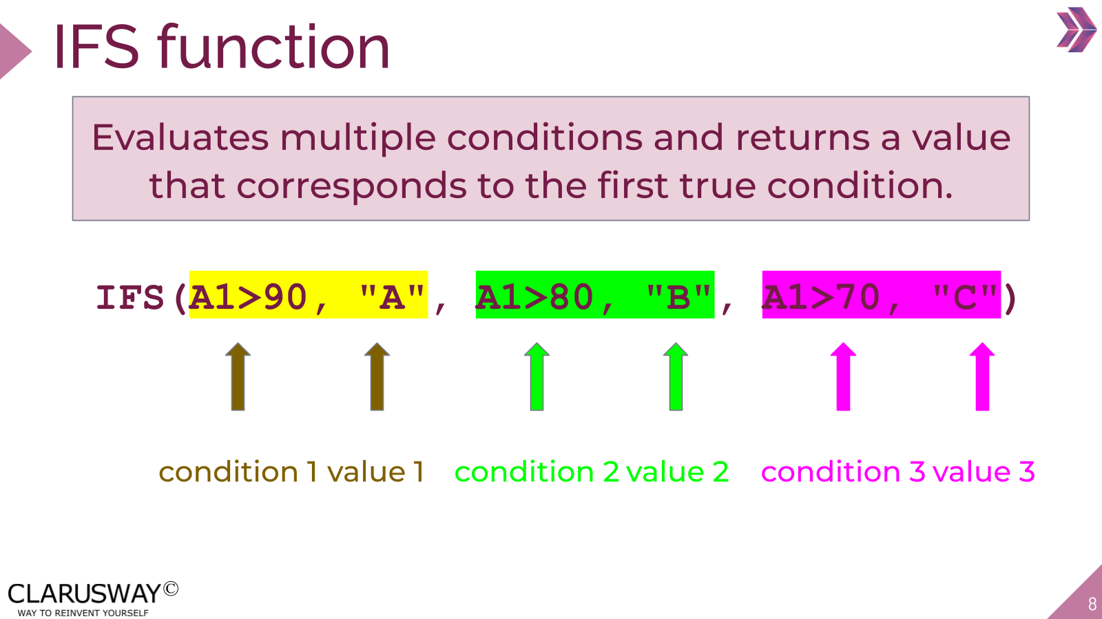

Use this space to take notes:

Slide 9
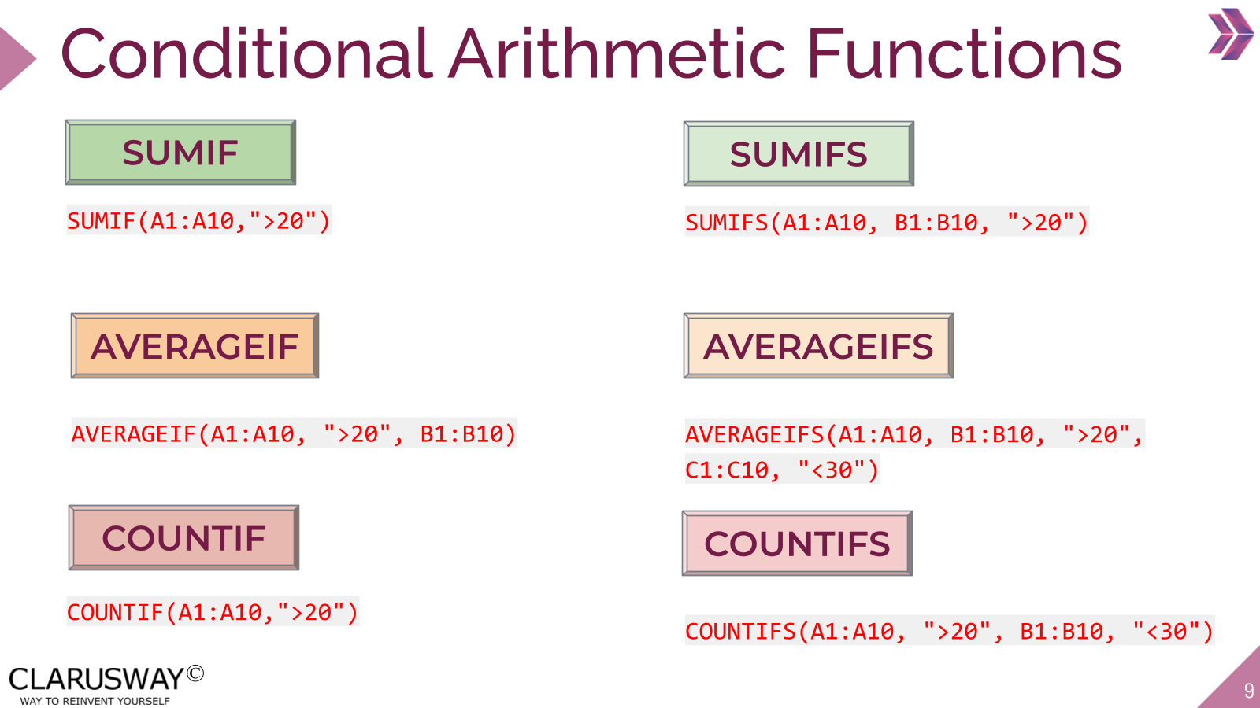

Use this space to take notes:

Slide 10
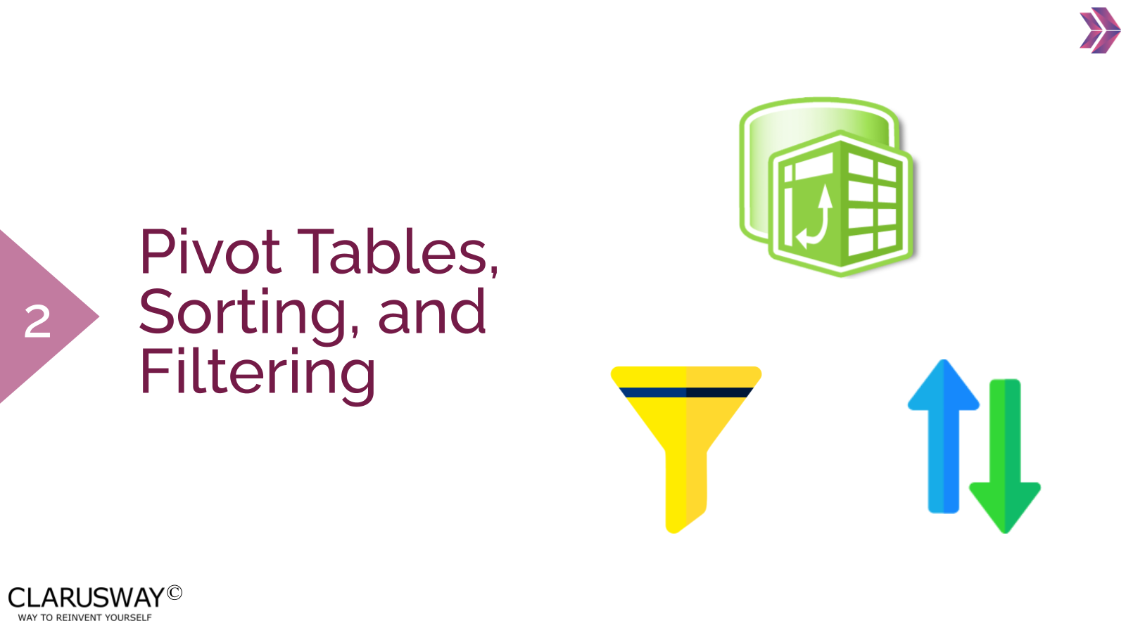

Use this space to take notes:

Slide 11
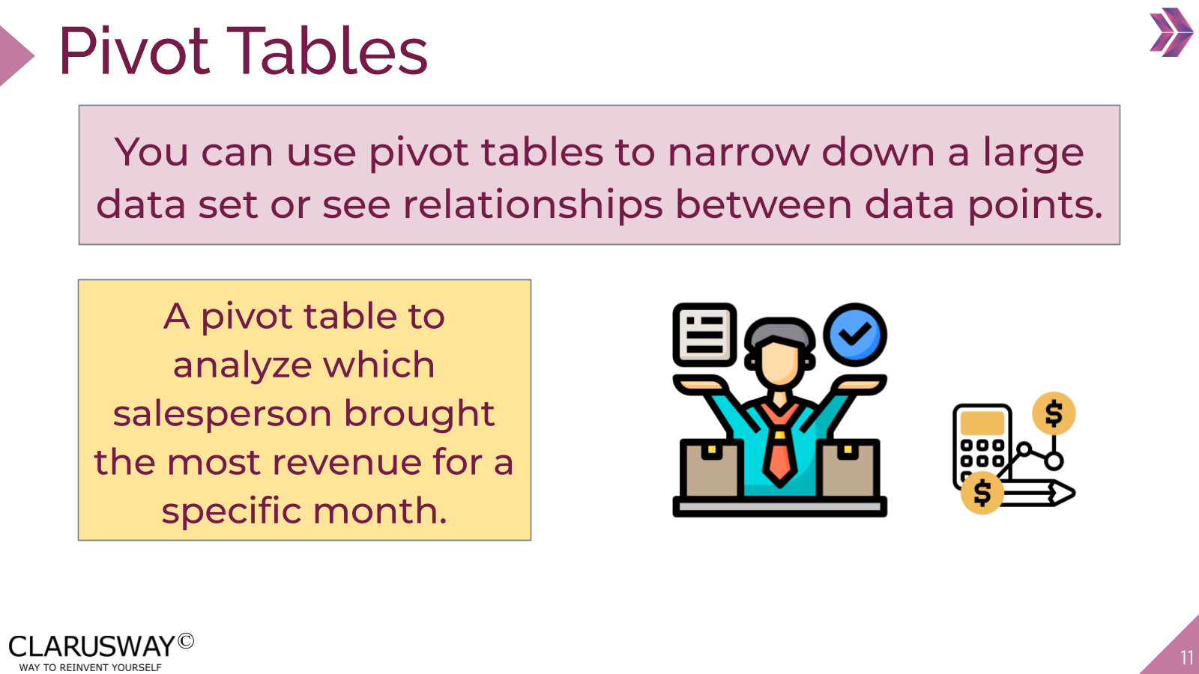

Use this space to take notes:

Slide 12
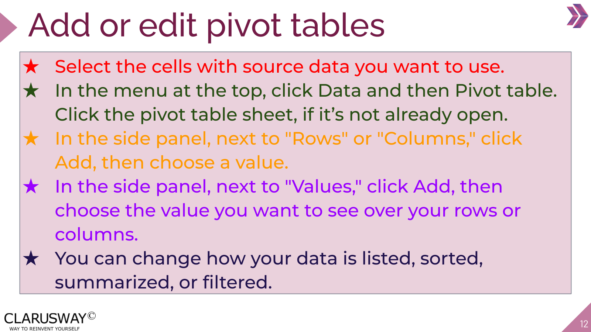

Use this space to take notes:

Slide 13
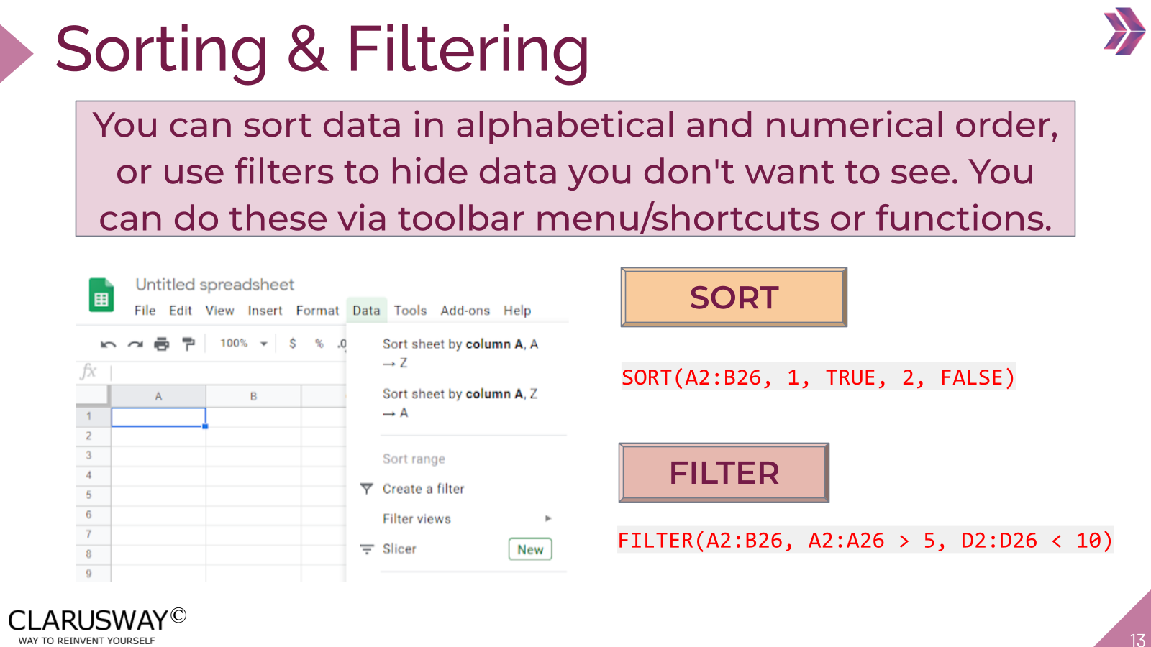

Use this space to take notes:

Slide 14 | Your Response
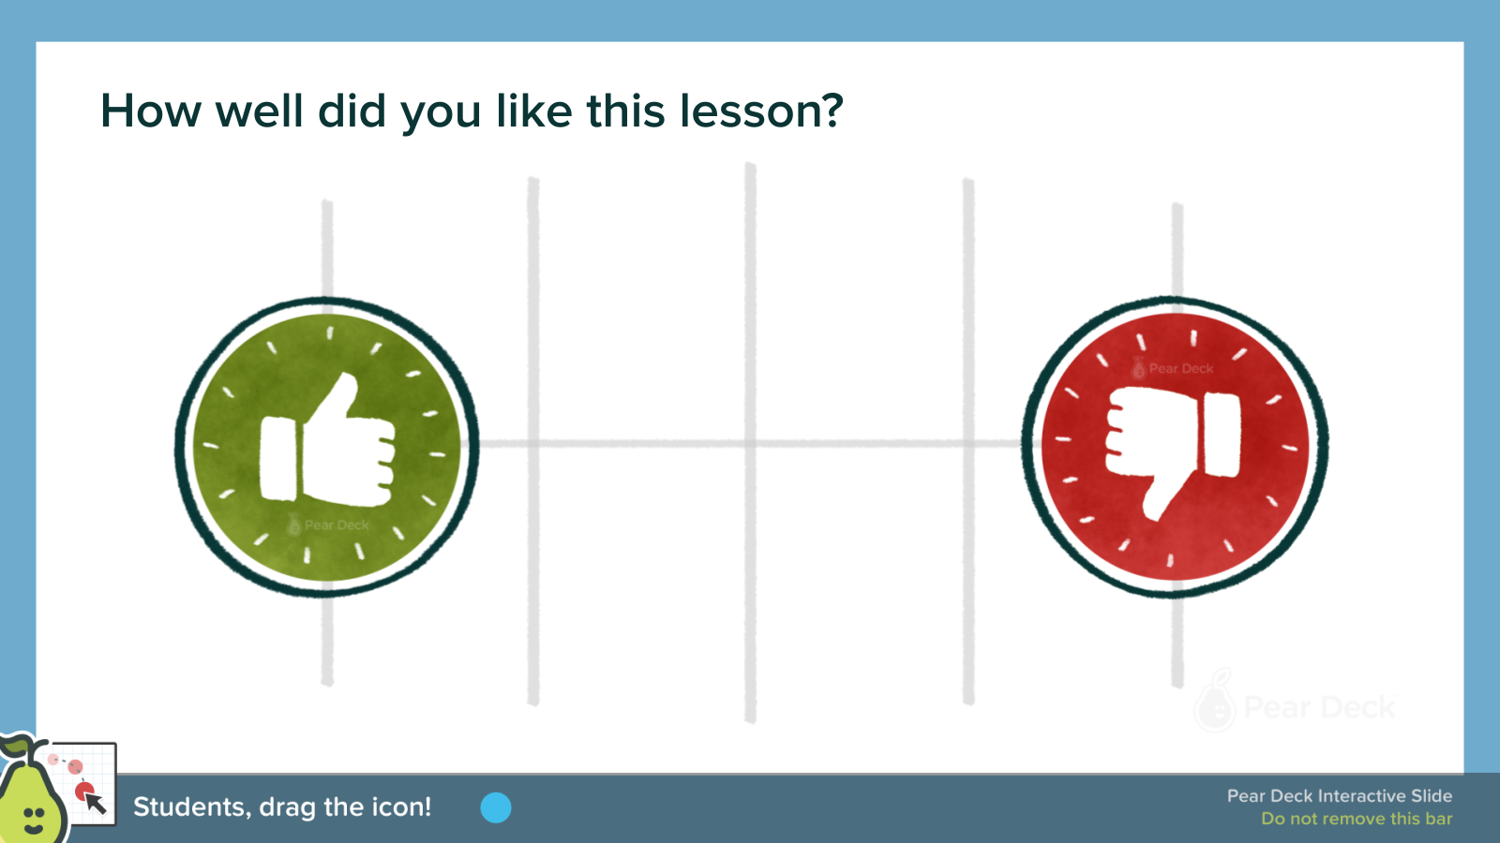 | 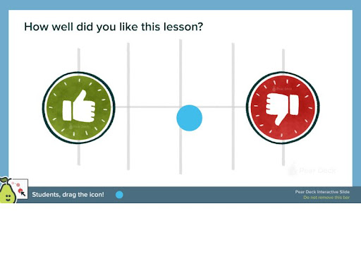
Use this space to take notes:

Slide 15
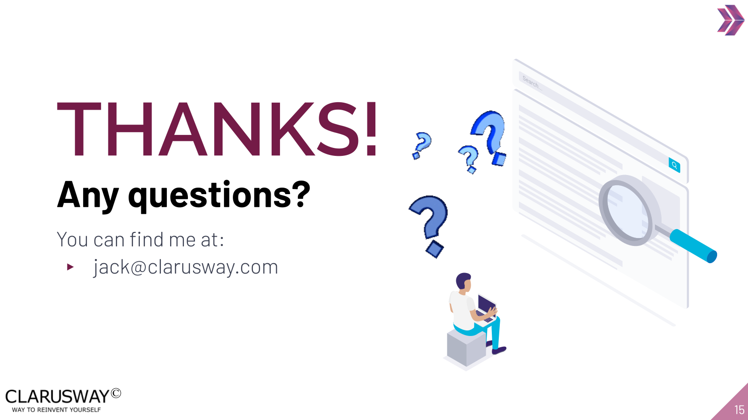

Use this space to take notes:

